EXAM SEATING ARRANGEMENT
-- Efficient Exam Allocation
Problem Title:
Examination Seating Arrangement.
Problem Statement :
The task is to design an Examination Seating Arrangement system that assigns each student a unique seat in an exam hall. The system takes the hall ticket number as input and provides clear details about the student’s seat number, hall, invigilator, and subject. The goal is to ensure that no two students are assigned the same seat, hall capacity is not exceeded, and seating information can be retrieved quickly and without errors.
Plan of Action:
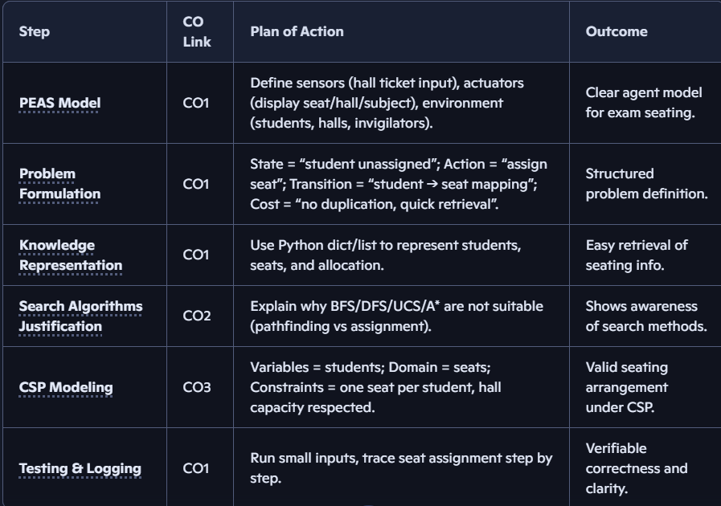

[CO wise Breakdown of Problem]
PEAS Model [CO-1]
P-Performance [How do we measure success]
- If the student has a clarity where his/her seat is allocated
- No errors in allocation of seat
- Ex: same seat for 2 members
- Quick retrieval of seating information [Student can find his seating details quickly without any delay]

E-Environment : [What world does an agent operates]
- Students
- Exam halls
- Class rooms
- Invigilators
- Exam Schedules
A-Actuators : [Actions that an agent makes]
- Displays Student Hall number
- Displays Student Seat number
- Displays Invigilator name allocated to that hall
- Displays students exam subject
S-Sensors: [What information does agent receives/input]
- Hall ticket Number becomes the input with which agent gives all exam related details.

Algorithms Used [CO-2]
The Exam Seating arrangement uses CSP(Constraint Satisfactory Problem) method in order to allocate seats to students

CSP[Constraint Satisfactory Problem] [CO-3]
Here,
Variables: [the things which agent needs to assign values to]
- So here Students need allocated seats so they become Variables.

Domain: [Set of all possible values that can be assigned to a variable]
- The available vacant seats becomes domain.
- Those seats are actual possible values that can be assigned to students.

Constraits: [Rules that must be satisfied by the agent]
- One student one seat.
- Hall capacity must not be exceeded.

Why only CSP?
It’s not a path finding problem. It is an assignment problem where agent needs to allocate seats to students under particular constraints.
Why not DFS,BFS,UCS,A*,Greedy algorithms?
They are path finding algorithms where as CSP is problem-solving framework .

Code:
# Exam Seating Arrangement with runtime input
# Dictionary mapping hall ticket numbers to seat details
seating_info = {
"HT001": {"seat": "Seat1", "hall": "Hall A", "invigilator": "Mr. Rao", "subject": "Math"},
"HT002": {"seat": "Seat2", "hall": "Hall A", "invigilator": "Mr. Rao", "subject": "Math"},
"HT003": {"seat": "Seat3", "hall": "Hall B", "invigilator": "Ms. Priya", "subject": "Physics"},
"HT004": {"seat": "Seat4", "hall": "Hall B", "invigilator": "Ms. Priya", "subject": "Physics"},
"HT005": {"seat": "Seat5", "hall": "Hall C", "invigilator": "Mr. Kumar", "subject": "Chemistry"}
}
# Take hall ticket number as input at runtime
hall_ticket = input("Enter your Hall Ticket Number: ")
# Check and display details
if hall_ticket in seating_info:
details = seating_info[hall_ticket]
print("\nExam Seating Details:")
print(f"Hall Ticket: {hall_ticket}")
print(f"Hall: {details['hall']}")
print(f"Seat: {details['seat']}")
print(f"Invigilator: {details['invigilator']}")
print(f"Subject: {details['subject']}")
else:
print("Invalid Hall Ticket Number. Please check again.")

Output:
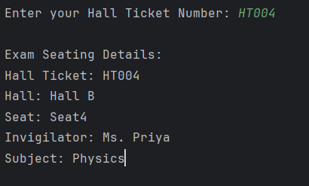

CO Attainments:
